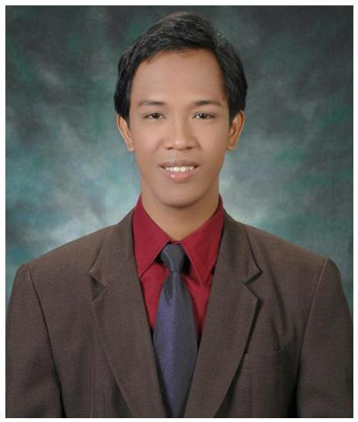**JAN MICHAEL ZAPATA**

Contact No: +639232190621 | 025228676

Email: jmzapata11@yahoo.com

Address: 348-A Matiisin St. Tondo, Manila PHL 1012

**OBJECTIVE:**

* Be part of a team that will give me opportunities to utilize the leadership, interpersonal and communication skills that I acquired from my previous and current job.

**EDUCATIONAL BACKGROUND:**

* ***University of the East (Tertiary)*** B.S. Information Technology Year: 2003 – 2007
* ***Jose Abad Santos High School (Secondary)*** Year: 1999 – 2003
* ***Pedro Guevarra Elementary School (Primary)*** Year: 1993 – 1999

**ACHIEVEMENTS AND AWARDS:**

* Consistent University Academic Scholar (UE, College of Computer Studies and Systems)
* Elected President of the 2006 College Student Council Polls (UE, College of Computer Studies and Systems)
* Technical Support of the Year (2008, Sykes Asia), Sales Champion (2010, HP Account, Convergys) and Two time Master Quality Representative (2012 - 2013, Convergys).

**SKILLS:**

* Excellent in verbal and written communication.
* Proficient at MS Office applications (Word, Excel, Access and PowerPoint).
* Exceptional in facilitating a class and process calibration.
* Familiar with ETL (Export, Transform and Load) and SAD (System Analysis and design) processes.
* Flexible and could quickly adapt to changing business processes.
* Fast learner, resourceful and very good in researching and process documentation.
* Has the ability to work in a time critical environment.

**CHARACTER REFERENCE:**

* ***Ms. Virgo Fatima Garrucho***

*(Manager, Convergys Quality Analytics)*

Mobile: +639275981867

* ***Ms. Ma. Carina Javelona***

*(Manager, Convergys Centralized Quality)*

Mobile: +639178156908

* ***Ms. Lyra Ruth De Leon***

*(Site Training Manager, Convergys Training)*

Mobile: +639175530397

* ***Mr. Ramon Omar Flores***

*(Manager, Convergys HP - IPG)*

Mobile: +639063041540

**WORK EXPERIENCE:**

* ***Analyst Reporting***

*(Convergys, October 2014 to Present)*

Task(s): Analyze and interpret quality data (CSAT, Quality Evaluations etc.) and provide reports to the stake holders. (2) ETL and SAD.

* ***Quality Representative***

*(Convergys, August 2011 to October 2014)*

Task(s): (1) Evaluate calls and submit reports to the operation. (2) Facilitate conference calls for process calibration. (3) Send weekly process updates provided by the clients.

* ***Associate Trainer***

*(Convergys, September 2010 to August 2011)*

Task(s): Facilitate new hire and refresher product trainings. (2) Facilitate conference calls with the clients for training process calibration. (3) Conduct final interview with applicants

* ***Technical Support***

*(Convergys, October 2009 to September 2010)*

Task(s): (1) Provide technical support to HP customers. (2) Offer products, services and plan upgrades to loyal consumers.

* ***Technical Support***

*(Sykes Asia, December 2007 to October 2009)*

Task(s): (1) Provide technical support to Pitney Bowes customers. (2) Offer products, services and plan upgrades to loyal consumers.